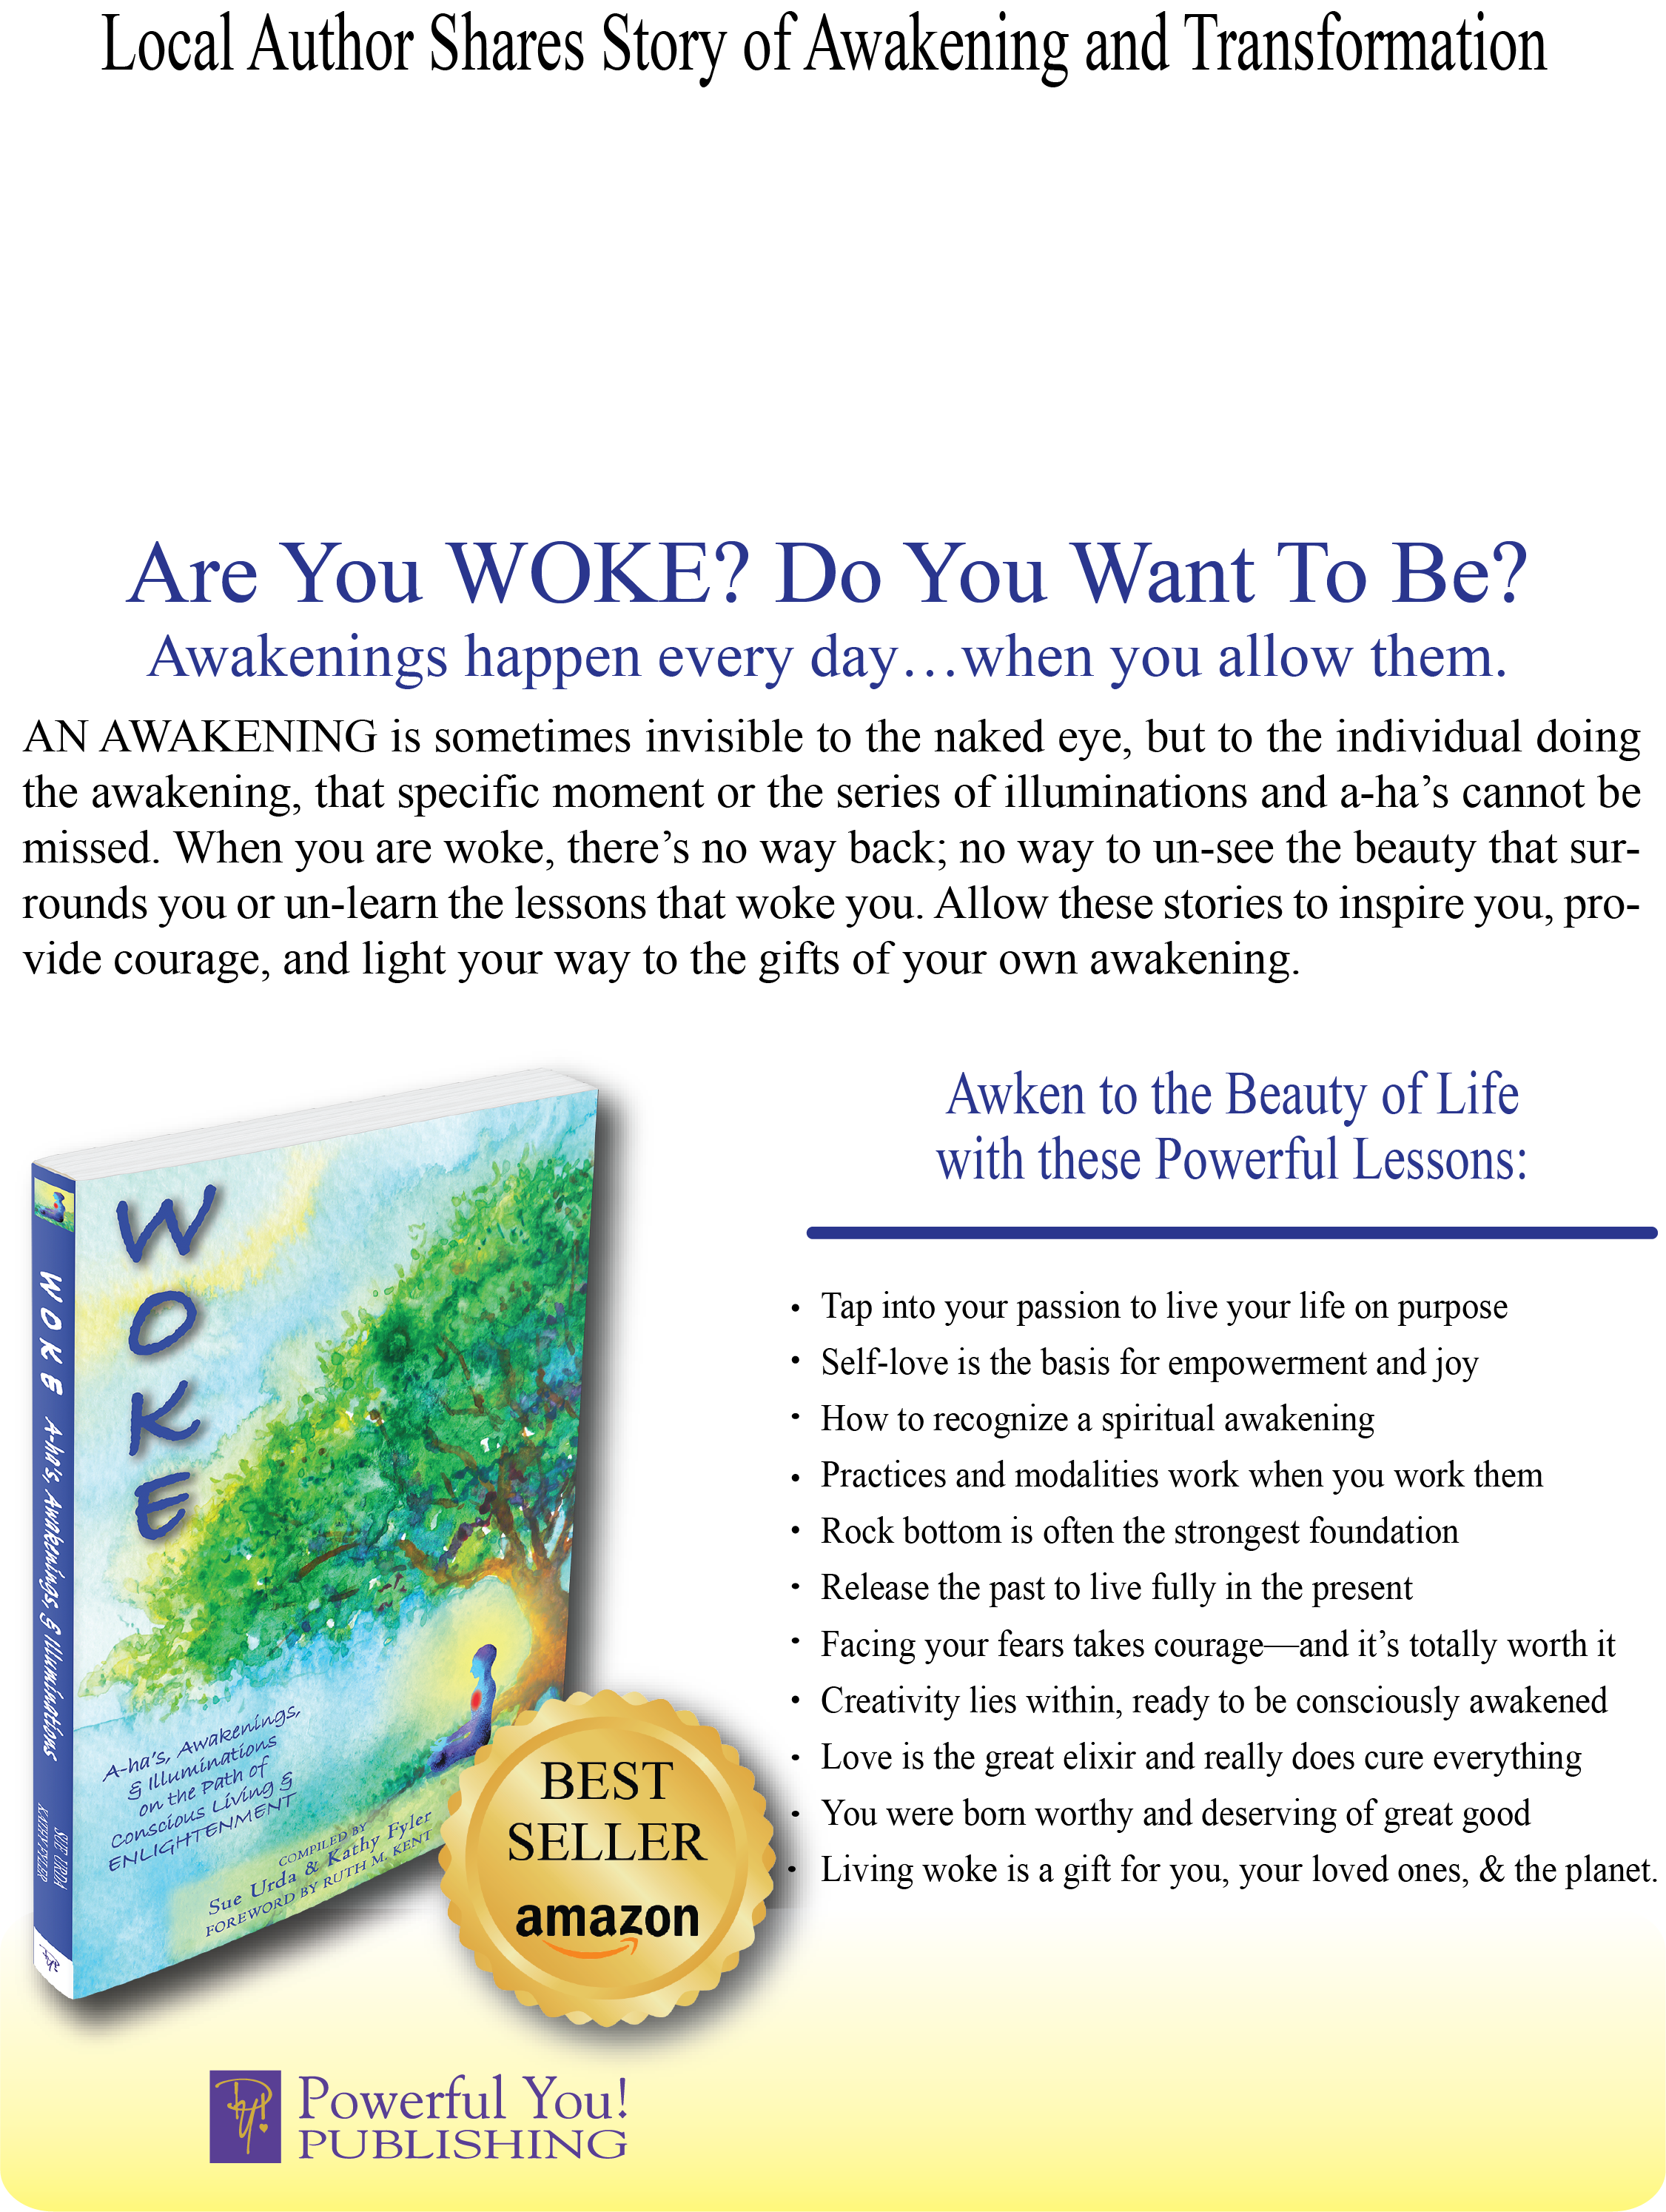

**About the Author**

**XXXXX**

**XXXXX**

**XXXXX**

**XXXXX**

**XXXXX**

**XXXXX**

**YOUR PHOTO  
HERE**

<<YOUR INFO HERE>>